**Assignment 2**

1)Write a program that checks if a given year is a leap year or not using both if-else and switch-case.

import java.util.Scanner;

public class LeapYear {

    public static void main(String args[]){

        int year;

        Scanner sc = new Scanner(System.in);

        System.out.println("Enter a Year to check if it is Leap year or not.");

        year = sc.nextInt();

        if (year % 400 == 0){

            System.out.println(year + " is a leap year");

        }

        else{

            if(year % 100 == 0){

                System.out.println(year + " is not a leap year");

            }

            else{

                if(year % 4 ==0){

                    System.out.println(year + " is a leap year");

                }

                else{

                    System.out.println(year + " is not a leap year");

                }

            }

        }

    }

}

Output :

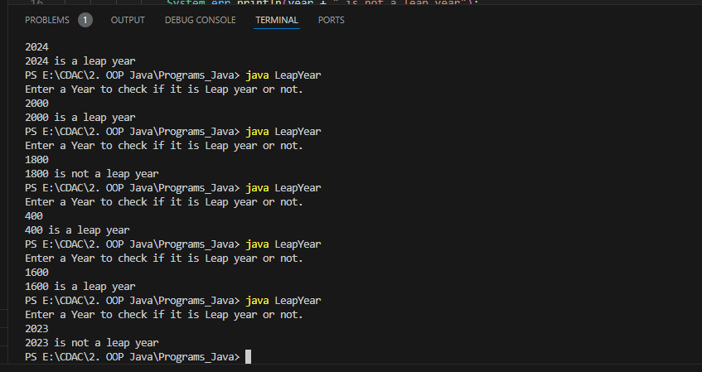

2)Implement a program that calculates the Body Mass Index (BMI) based on height and weight input using if-else to classify the BMI int categories (underweight, normal weight, overweight,etc).

import java.util.Scanner;

public class BMICalculator {

    public static void main(String[] args){

        Scanner sc = new Scanner(System.in);

        System.out.println("Enter height(m) and weight(kg)");

        double height = sc.nextDouble();

        double weight = sc.nextDouble();

        double bmi = weight / (height*height);

        System.out.printf("Calculated Body Mass : %.2f\n", bmi);

        if(bmi <= 18.5){

            System.out.println("Underweight");

        }

        else if(bmi>= 18.5 && bmi<=24.9){

            System.out.println("Normal Weight");

        }

        else if(bmi >=25 && bmi<=29.9){

            System.out.println("Overweight");

        }

        else{

            System.out.println("Obesity");

        }

    }

}

Output:

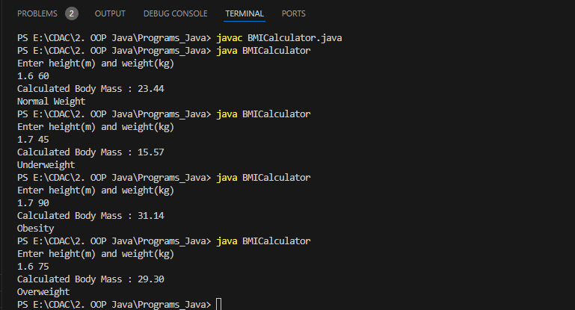

3)Write a program that checks if a person is eligible to vote based on their age.

import java.util.Scanner;

public class CheckEligibility {

    public static void main(String args[]){

        Scanner sc = new Scanner(System.in);

        System.out.println("Enter your age");

        int age = sc.nextInt();

        if(age >= 18){

            System.out.println("You are eligible to vote");

        }

        else{

            System.out.println("You are not eligible to Vote");

        }

    }

}

Output :

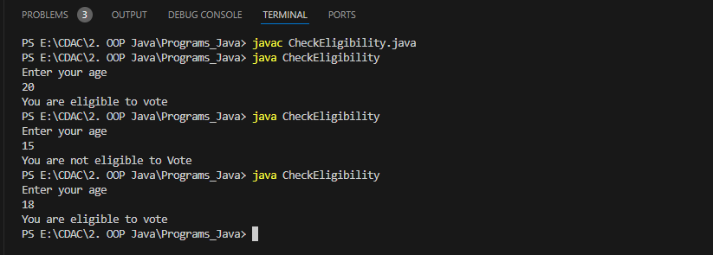

4)Write a program that takes a month (1-12) and prints the corresponding season (Winter, Spring, Summer, Autumn) using a switch case

import java.util.Scanner;

public class CheckSeason {

    public static void main(String[] args) {

        Scanner sc = new Scanner(System.in);

        System.out.println("Enter a month between 1 to 12");

        int month = sc.nextInt();

        switch(month){

            case 1:

            case 2:

            case 12:

                System.out.println("Winter Season");

                break;

            case 3:

            case 4:

            case 5:

                System.out.println("Spring Season");

                break;

            case 6:

            case 7:

            case 8:

                System.out.println("Summer Season");

                break;

            case 9:

            case 10:

            case 121:

                System.out.println("Autmn Season");

                break;

            default:

                System.out.println("Invalid! Enter a valid month between 1 to 12");

                break;

        }

    }

}

Output :

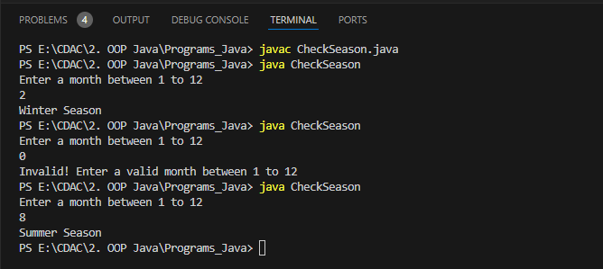

5)Write a program that allows the user to select a shape (Circle, Square, Rectangle, Triangle) and then calculates the area based on user-provided dimensions using a switch case.

import java.util.*;

public class CalculateArea {

    public static void main(String[] args) {

        Scanner sc = new Scanner(System.in);

        System.out.println("Select a shape Enter your choise \n 1. Circle \n 2. Square \n 3. Rectangle \n 4.Triangle");

        int ch = sc.nextInt();

        switch(ch){

            case 1:

                System.out.println("Enter the radius of the circle");

                double r = sc.nextDouble();

                double area = Math.PI * r * r;

                System.out.printf("Area of Circle= %.2f\n", area);

                break;

            case 2:

                System.out.println("Enter the side length of the square");

                double side = sc.nextDouble();

                area = side * side;

                System.out.printf("Area of Square= %.2f\n", area);

                break;

            case 3:

                System.out.println("Enter the length and width of the rectangle");

                double l = sc.nextDouble();

                double w = sc.nextDouble();

                area = l * w;

                System.out.printf("Area of Rectangle= %.2f\n", area);

                break;

            case 4:

                System.out.println("Enter the base and height of the rectangle");

                double h = sc.nextDouble();

                double b = sc.nextDouble();

                area = 0.5 * h * b;

                System.out.printf("Area of Triangle= %.2f\n", area);

                break;

            default:

                System.out.println("invalid choise.");

                break;

        }

    }

}

Output :

